# Báo cáo môn Phát triển phần mềm theo chuẩn kỹ năng ITSS

Homework 1

Họ và Tên: Lê Duy Nghiêm

MSSV: 20215102

Lớp 147730

Nhóm: 8

Contents

Báo cáo môn Phát triển phần mềm theo chuẩn kỹ năng ITSS 1

Bài 1: 2

1. Create an account in github 2

2. Create a private repository in github, join with all members in your group 2

Bài 2: 2

1. HelloWorld.java: Ask an user to enter his/her name, then display hello to that name 2

2. Implement MVC tutorial 2

3. Implement Calculator, using MVC model with 2 version: Swing and JavaFX (SceneBuilder) 2

Bài 3: 3

Perform git actions: 3

Table of Figures

Figure 1: HelloWorld 3

Figure 2: Swing calculator 3

Figure 3: JavaFX calculator 4

Bài 1:

1. Create an account in github
2. Create a private repository in github, join with all members in your group
   1. Naming your project name
   2. Create sub-directory (homework1)

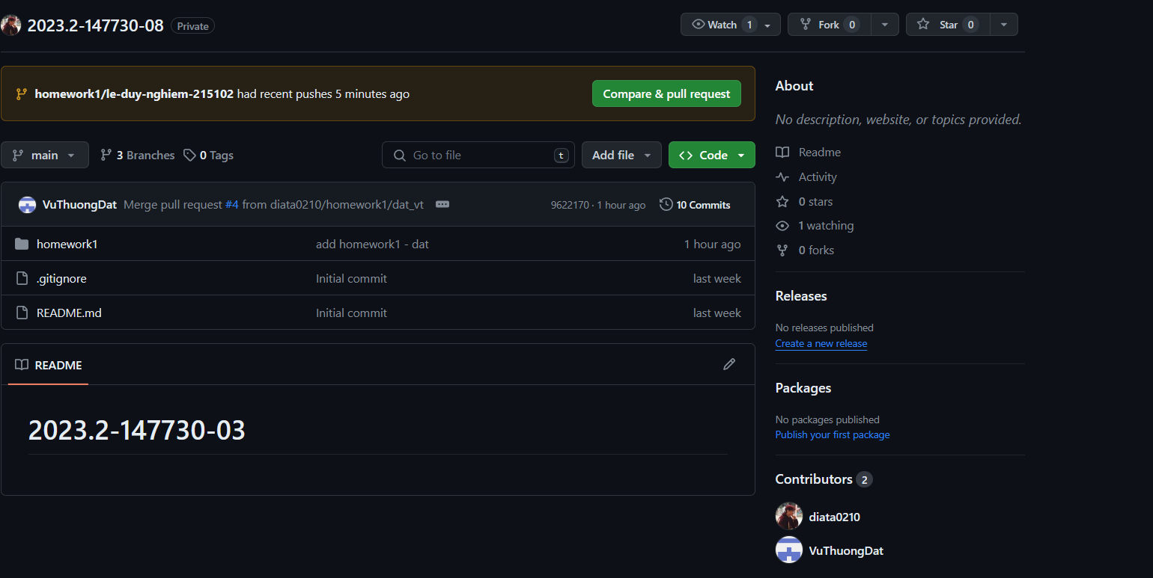

Bài 2:

1. HelloWorld.java: Ask an user to enter his/her name, then display hello to that name

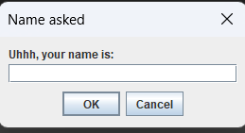

Figure 1: HelloWorld

1. Implement MVC tutorial
2. Implement Calculator, using MVC model with 2 version: Swing and JavaFX (SceneBuilder)
3. A screenshot of a computer

   Description automatically generated

Figure 2: Swing calculator

Figure 3: JavaFX calculator

Bài 3:

Perform git actions:

1. Add, remove, modify, commit, push, pull,merge (resolve conflict), create branch, merge branch
2. Take screenshoot to prove that you have done all actions

